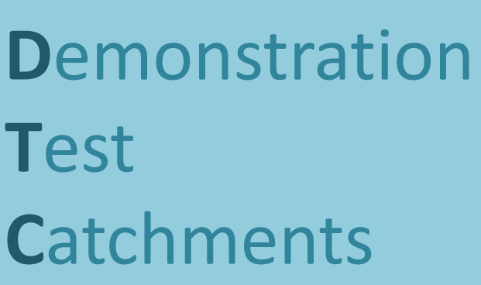**Demonstrating Test Catchments.**

**January 21st and 22nd 2013**

Mary Sumner House, Meeting Rooms

24 Tufton St., London SW1P 3RB

A two day conference and seminar to present and discuss the preliminary results from the DEFRA funded Demonstration Test Catchments research platform.

This two day event will offer the opportunity for policy makers, delivery agencies, land and water managers and catchment managers to learn about the catchment scale water quality and land management research currently underway in the Demonstration Test Catchments research platform.

**Day one (10-5 pm) – DTC the Last Two Years** - will provide an overview of the catchment scale research and examples of the lessons learned so far, with opportunities for questions, discussion and accessing further details throughout. It will be structured into 4 sections:

* Understanding the problem
* Implementing Measures
* Acceptance and take-up
* Evaluating success

**Day two (10- 1 pm) – DTC the Next Two Years** - will provide an opportunity for more in-depth discussions led by Defra and the EA between the science research teams and stakeholders concerned with water quality. The intention is to develop a dialogue and help guide future work in the DTC (and related) research platforms in the context of the existing and emerging policy approaches and delivery challenges in:

* Designing water quality monitoring approaches
* Engaging stakeholders in decision-making at catchment scales
* Understanding diffuse pollution risk: what does DTC research tell us about the spatial and temporal factors at play in the mobilisation, transport and impact of diffuse pollution?
* Planning and implementing diffuse pollution mitigation measures
* Analysis of farm practice data from baseline surveys – what does it tell us about farming/farm advisory services/ the culture of farming and future farm security
* Decision support tools and water quality modelling – future needs.

The workshop is free but numbers are limited so please contact Bob Harris at [robert.harris@defra.gsi.gov.uk](mailto:r.harris@defra.gsi.gov.uk) to register and for further details